**Bajaj Finserv Health Challenge (Qualifier 1)**

**Note: This is a full stack challenge – involves both backend and frontend parts. Completion of both challenges are required for all candidates.**

*Candidates are free to use online resources including, but not limited to* [*OpenAI ChatGPT,*](https://chatgpt.com/) [*Google Gemini,*](https://gemini.google.com/) [*Anthropic Claude*](https://cluade.ai/) *and* [*StackOverflow.*](https://stackoverflow.com/)

*Note: Refer to the end for submission instructions*

# Backend

## Objective

Build and deploy a REST API with one endpoint that accepts requests with both GET and POST methods.

**POST** method endpoint takes in the request (JSON) and returns the following:

1. Status
2. User ID

### 3. College Email ID 4. College Roll Number

1. Array for numbers
2. Array for alphabets
3. Array with the highest lowercase alphabet (refer to logic explanation below)

**GET** method endpoint doesn’t take any user input, it just returns an *operation_code*

- ***Please refer to Annexure (A) for request/response samples***

# Hosting

Any provider of your choice, if you don’t have one already, please use [Heroku](https://www.heroku.com/) [/ Netlify](https://www.netlify.com/) [/ Vercel /](https://vercel.com/) Firebase or any other provider that provides REST API deployment.

# Logic – (2 Parts)

## 1. Route: /bfhl | Method: POST

1. Example[: https://testbfhl.herokuapp.com/bfhl [](https://testbfhl.herokuapp.com/bfhl)POST Method]
2. Response should always contain your user_id (fullname_dob) in the following format

i. "user_id": {full_name_ddmmyyyy}

E.g.: "user_id”: "john_doe_17091999"

1. “is_success” should be returned in the response to mark the status of operation. It can be true / false

**______________________**

## 2. Route: /bfhl | Method: GET

1. Example[: https://testbfhl.herokuapp.com/bfhl [](https://testbfhl.herokuapp.com/bfhl)GET Method]
2. ***Doesn’t take any input from the user.*** *The endpoint will be hit with a GET request, that’s it.*
3. Expected HTTP Status Code: 200
4. Expected Response Body (hardcoded) (JSON):

{

“operation_code”:1

}

*Note: Be sure to follow other best practices including exception handling, input validation and others.*

# Annexure (A) - (ONLY FOR POST REQUEST)

## Example A

*Note: If an alphabet is present in the input, it will always be a single character, never a word. And “highest_lowercase_alphabet” refers to the lowercase alphabet from the input array which occurs last in the a-z series.*

## Request

{

"data": [“M”,”1”,”334”,”4”,”B”,”Z”,”a”]

}

## Response

{

"is_success": true,

"user_id": "john_doe_17091999",

“email” : “john@xyz.com”,

“roll_number”:”ABCD123”,

"numbers": [“1”,”334”,”4”],

"alphabets": [“M”,”B”,”Z”,”a”],

“highest_lowercase_alphabet”:[“ a”]

}

**Example B**

## Request

{

"data": [“2”,”4”,”5”,”92”]

}

## Response

{

"is_success": true,

"user_id": "john_doe_17091999", “email” : “john@xyz.com”,

“roll_number”:”ABCD123”,

"numbers": [“2”,”4”,”5”,”92”],

"alphabets": [],

“highest_lowercase_alphabet”:[]

}

**Example C**

## Request

{

"data": ["A",”C”,”Z”,”c”,”i”]

}

## Response

{

"is_success": true,

"user_id": "john_doe_17091999", “email” : “john@xyz.com”,

“roll_number”:”ABCD123”,

"numbers": [],

"alphabets": ["A",”C”,”Z”,”c”,”i”],

“highest_lowercase_alphabet”:[“i”]

}

# Frontend

## Objective

Develop and deploy a frontend application that uses the backend you’ve developed to process the input and get response, then render it on frontend. (Preferably React based – including frameworks like Next.js, but that’s optional).

## Logic

1. The application should have a text input that accepts JSONs that are from the previous section’s

(backend’s) request. Example - { "data": ["A",”C”,”z”] }

1. The frontend application should call the REST API that you’ve created to process the data in request and return the response as per the logic mentioned in backend challenge.

## Details

Create a user interface with the following features:

1. Text input field and submit button:
   * + Accepts only valid JSON input
     + Validates JSON format on submission, show error in case of invalid input
     + Calls the REST API that you’ve created, with payload from the text input
     + Gets the response and then uses the following logic to render it
2. Multi-Select Dropdown:
   * + Appears after valid JSON submission
     + Contains the following options:
       1. Alphabets
       2. Numbers
       3. Highest lowercase alphabet
3. Response shown on frontend will be basis options selected from dropdown. E.g. if user selects

Alphabets & Numbers then response should render data associated only with alphabets & numbers

1. Also, the website title should be your roll number

Eg: In the following image, “Google” is the title of the first tab.



**Sample Output:**

In case, user selects only “Numbers” from the multiselect filter, response will look as following:

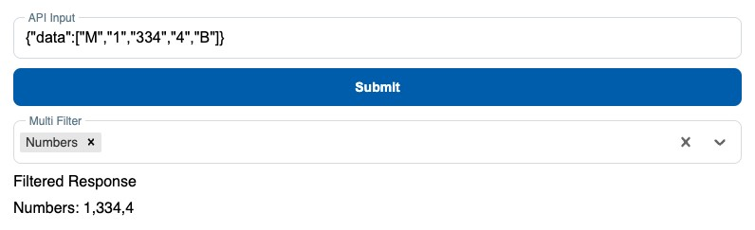

**Submission**

* 1. Host your backend & frontend applications
  2. Share your backend API endpoint (ending in /bfhl) and frontend application URL in the following form: